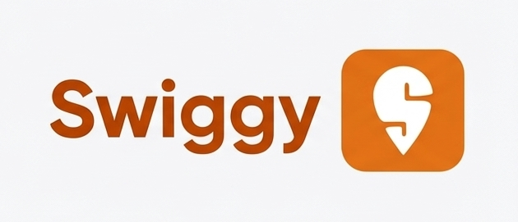
Product Dissection for Swiggy

Company Overview:
Swiggy is an online food delivery platform that connects customers with nearby restaurants and delivery partners through a mobile app and website. It allows users to discover restaurants, browse digital menus, place orders, and track deliveries in real time, while restaurants use the platform to reach more customers and manage orders efficiently. For this case study, we focus on the core food delivery flow that links customers, restaurants, and delivery partners into one integrated system.

Product Dissection and Real-World Problems Solved by Swiggy:
Swiggy, a leading online food delivery platform in India, tackles everyday challenges around access to convenient, reliable, and diverse meal options through a seamless digital experience. By connecting customers, restaurants, and delivery partners in one integrated system, Swiggy transforms the traditionally fragmented process of ordering food into a few simple taps on a mobile app or website. Instead of spending time travelling, waiting in queues, or calling multiple restaurants, users can browse menus, compare options, place orders, and track deliveries in real time from wherever they are. This core value proposition addresses the growing need for time-saving, on-demand services in busy urban lifestyles, where cooking regularly or dining out is often inconvenient.

One of the major real-world problems Swiggy solves is the limitation of time and access to variety. Many users struggle to balance work, study, and personal life, leaving little time for meal preparation or restaurant visits, and often with limited awareness of nearby food options. Swiggy partners with a wide network of local and branded restaurants to bring multiple cuisines, price points, and dietary preferences into a single, searchable interface. Features such as filters, search, and personalised recommendations based on past orders help users quickly discover relevant dishes and restaurants instead of being overwhelmed by choice. This combination of restaurant discovery and easy ordering effectively addresses the challenge of finding suitable food options under time pressure.

Swiggy also responds to issues of delivery reliability and transparency that existed with informal or restaurant-managed delivery systems. Traditionally, customers had little visibility into order status, delivery time, or who was handling their food, often leading to uncertainty and frustration. Swiggy’s dedicated delivery partner network, route optimisation, and live order tracking provide clear visibility from order placement to doorstep delivery. Real-time updates, estimated delivery times, and support channels reduce anxiety around delays and missed orders, while ratings and reviews build trust in both restaurants and delivery partners. Secure digital payments and multiple payment options further streamline the experience and remove friction around cash handling.

For restaurants, Swiggy addresses the problem of limited customer reach and operational inefficiencies. Smaller and mid-sized outlets often lack the resources to build their own delivery infrastructure or marketing channels, restricting them to nearby walk-in customers. By listing on Swiggy, restaurants gain access to a large online customer base, digital menus, and order management tools that help them handle demand more systematically. This not only increases their revenue potential but also allows them to focus on food quality while Swiggy manages logistics and customer interface. In parallel, the platform creates income opportunities for thousands of delivery partners, connecting them to flexible work tied directly to customer demand.

In essence, Swiggy’s product design dissects and solves multiple interconnected real-world problems: lack of time, limited food discovery, unreliable delivery, and restricted restaurant reach. Through integrated features like restaurant discovery, personalised recommendations, real-time tracking, ratings and reviews, and secure payments, Swiggy converts a complex offline journey into a smooth, transparent, and scalable digital service. This holistic approach not only enhances daily convenience for customers but also reshapes the food ecosystem by empowering restaurants and delivery partners, making Swiggy an integral part of modern urban living.

Case Study: Real-World Problems and Swiggy's Innovative Solutions
The following case studies highlight how Swiggy's platform features translate into practical, everyday solutions for its key users — customers, students, and restaurant owners. Each scenario reflects a genuine challenge faced in the real world and demonstrates how Swiggy's design decisions directly address those pain points, making the platform relevant, reliable, and impactful across diverse user groups.

Case Study 1: The Time-Pressed Professional
Real-World Challenge:
Rohit, a 28-year-old software engineer in Bengaluru, works long hours and rarely has time to cook or visit a restaurant during weekdays. By the time he finishes work, most nearby eateries are either too far or too crowded. He needs a fast, reliable way to get a hot meal delivered to his doorstep without spending time planning or travelling.
Swiggy's Solution:
Swiggy solves this by offering a location-based restaurant discovery system that instantly shows available restaurants near Rohit's address, along with estimated delivery times. Personalised recommendations based on his past orders help him decide quickly without scrolling endlessly. Once he places the order, real-time tracking lets him monitor every step — from the restaurant preparing his food to the delivery partner arriving at his door. Swiggy's "Scheduled Delivery" feature even allows him to pre-order meals in advance, giving him full control over his meal routine despite a hectic schedule.

Case Study 2: The Budget-Conscious Student
Real-World Challenge:
Priya, a 22-year-old postgraduate student in Kolkata, lives in a hostel with limited cooking facilities and a tight monthly budget. She wants to order food regularly but struggles to find affordable options and often worries about hidden charges or unreliable delivery from unknown local outlets.
Swiggy's Solution:
Swiggy addresses this through its filter and sort features, which allow Priya to browse restaurants by price range, offers, and ratings — helping her find quality meals within her budget. The platform's transparent pricing model shows item costs, delivery fees, taxes, and applicable discounts clearly before checkout, eliminating surprise charges. Swiggy's regular promotional offers, discount codes, and loyalty-based cashback through Swiggy One membership further reduce her per-order spending. Verified ratings and reviews from other customers also give her confidence in choosing reliable restaurants, solving the trust problem associated with ordering from unfamiliar places.

Case Study 3: The Small Restaurant Owner
Real-World Challenge:
Arjun runs a small home-style Bengali food restaurant in Kolkata with great food but limited walk-in customers due to its location in a narrow lane away from the main street. He lacks the resources to hire delivery staff, build a website, or invest in marketing, which restricts his growth despite strong demand from nearby residents.
Swiggy's Solution:
Swiggy's restaurant partner program solves this by providing Arjun with a ready-made digital storefront, a built-in customer base, and a managed delivery network — all without upfront infrastructure costs. His menu is listed on the platform with photos, descriptions, and real-time availability controls that he can manage easily. Swiggy's delivery partner fleet handles all logistics, so Arjun can focus entirely on food preparation and quality. Data insights from the Swiggy partner dashboard show him peak ordering hours, popular dishes, and customer feedback, helping him make informed decisions to grow his business steadily.

Conclusion:
These case studies collectively illustrate that Swiggy is not just a food ordering app but a multi-sided platform built to solve real friction points across its entire ecosystem. Whether it is saving time for a busy professional, making food affordable for a student on a budget, or helping a small restaurant owner grow beyond geographical limitations, Swiggy's features are thoughtfully designed to deliver measurable value to every stakeholder it serves.

Top Features of Swiggy:
- Location-Based Restaurant Discovery: Swiggy uses the user's real-time location to display nearby restaurants, estimated delivery times, and availability. This ensures that users only see options that can actually deliver to them, making the browsing experience relevant and efficient.
- Smart Search and Filters: Users can search for specific dishes, cuisines, or restaurants and apply filters such as price range, dietary preference (veg/non-veg), ratings, delivery time, and ongoing offers. This helps users find exactly what they want without scrolling through irrelevant options.
- Real-Time Order Tracking: Once an order is placed, Swiggy provides live tracking that shows every stage — order confirmed, food being prepared, delivery partner picked up, and out for delivery. This transparency builds trust and reduces anxiety around waiting times.
- Personalised Recommendations: Based on a user's order history, location, time of day, and browsing behaviour, Swiggy surfaces personalised restaurant and dish suggestions. This makes repeat ordering faster and helps users discover new options aligned with their taste preferences.
- Swiggy One Membership: Swiggy's subscription program offers benefits like free deliveries, exclusive discounts, and priority support for a fixed monthly or annual fee. This rewards loyal users and encourages consistent usage of the platform over competitors.
- Scheduled Delivery: Users can pre-schedule food orders for a specific time, which is especially useful for meal planning, office lunches, or events. This feature removes last-minute ordering pressure and helps restaurants manage incoming demand better.
- Multiple Payment Options: Swiggy supports UPI, credit/debit cards, net banking, digital wallets, and cash on delivery. A transparent checkout screen displays item costs, delivery fees, taxes, and applied discounts before final payment, eliminating hidden charges.
- Ratings and Reviews: After every order, users can rate the restaurant and the delivery experience separately. These verified ratings and written reviews help future customers make informed decisions and also push restaurants to maintain quality standards.
- Swiggy Instamart: Beyond food delivery, Swiggy offers quick grocery and essential delivery through Instamart, often within 10–15 minutes. This extends the platform's utility beyond meals and makes it a daily-use super-app for urban users.
- In-App Customer Support: Swiggy provides real-time chat-based support within the app for issues like wrong orders, late deliveries, or refund requests. Quick resolution of complaints improves user trust and retention on the platform.

Schema Description:

The schema design for Swiggy's food delivery platform is structured to capture every key interaction between its three primary stakeholders — customers, restaurants, and delivery partners. The entities, attributes, and relationships defined below reflect the real-world flow of a food order, from discovery and placement to payment and delivery.

User Entity:
Represents every registered customer on the platform.

Attribute | Description
UserID (PK) | Unique identifier for each user
name | Full name of the user
email | Registered email address
phone | Contact number
address | Default delivery address
signup_date | Date the account was created
is_active | Whether the account is currently active

Restaurant:
Represents every food outlet listed on the platform.

Attribute | Description
RestaurantID (PK) | Unique identifier for each restaurant
name | Name of the restaurant
address | Physical location of the restaurant
cuisine_type | Type of cuisine served
phone | Contact number
rating | Average customer rating
opening_time | Daily opening time
closing_time | Daily closing time
is_active | Whether the restaurant is currently accepting orders

MenuItem:
Represents individual food items listed under a restaurant.
Attribute | Description
MenuItemID (PK) | Unique identifier for each menu item
RestaurantID (FK) | Restaurant this item belongs to
name | Name of the dish
description | Short description of the dish
Price | Cost of the item
category | Category such as Starter, Main Course, Dessert
is_veg | Whether the item is vegetarian
is_available | Whether the item is currently available

Order:
Represents a single food order placed by a user.
Attribute | Description
OrderID (PK) | Unique identifier for each order
UserID (FK) | User who placed the order
RestaurantID (FK) | Restaurant the order was placed at
total_amount | Final payable amount
order_status | Current status: Placed, Preparing, Out for Delivery, Delivered
order_time | Timestamp when the order was placed
estimated_delivery_time | Expected delivery time
actual_delivery_time | Actual time the order was delivered
OfferID (FK) | Offer applied to this order (if any)

OrderItem:
Represents individual items within a single order.

Attribute | Description
OrderItemID (PK) | Unique identifier for each order item
OrderID (FK) | Order this item belongs to
MenuItemID (FK) | Menu item that was ordered
quantity | Number of units ordered
item_price | Price at the time of ordering

DeliveryPartner:
Represents the delivery agents working on the platform.
Attribute | Description
DeliveryPartnerID (PK) | Unique identifier for each delivery partner
name | Full name of the delivery partner
phone | Contact number
vehicle_type | Type of vehicle used for delivery
current_status | Available, On Delivery, Offline
rating | Average customer rating

Delivery:
Represents the delivery record linked to each order.
Attribute | Description
DeliveryID (PK) | Unique identifier for each delivery
OrderID (FK) | Order being delivered
DeliveryPartnerID (FK) | Partner handling this delivery
pickup_time | Time the order was picked up from restaurant
drop_time | Time the order was delivered to user
delivery_status | Picked Up, In Transit, Delivered
current_location | Real-time location of the delivery partner

Payment:
Represents the payment transaction for each order.

Attribute | Description
PaymentID (PK) | Unique identifier for each payment
OrderID (FK) | Order this payment is linked to
amount | Total amount paid
payment_mode | UPI, Card, Wallet, Cash
payment_status | Pending, Completed, Failed, Refunded
transaction_id | Unique transaction reference number
payment_time | Timestamp of the payment

Review:
Represents feedback submitted by a user after an order.
Attribute | Description
ReviewID (PK) | Unique identifier for each review
UserID (FK) | User who submitted the review
RestaurantID (FK) | Restaurant being reviewed
OrderID (FK) | Order the review is linked to
rating | Numeric rating out of 5
comment | Written feedback
created_at | Timestamp of the review

Relationships are:

Relationship | Type | Description
User → Order | 1 to Many | One user can place multiple orders
Restaurant → Order | 1 to Many | One restaurant can receive multiple orders
Restaurant → MenuItem | 1 to Many | One restaurant can have multiple menu items
Order → OrderItem | 1 to Many | One order can contain multiple items
MenuItem → OrderItem | 1 to Many | One menu item can appear in multiple order items
Order → Payment | 1 to 1 | Each order has exactly one payment record
Order → Delivery | 1 to 1 | Each order has exactly one delivery record
DeliveryPartner → Delivery | 1 to Many | One delivery partner can handle multiple deliveries
User → Review | 1 to Many | One user can write multiple reviews
Restaurant → Review | 1 to Many | One restaurant can receive multiple reviews
Order → Review | 1 to 1 | Each order can have at most one review

ER Diagram:

Let's construct an ER diagram that vividly portrays the relationships and attributes of the entities within the Swiggy schema. This ER diagram will serve as a visual representation, shedding light on the pivotal components of Swiggy's data model. By employing this diagram, we can gain a clearer grasp of the intricate interactions and connections that define the platform's dynamics.

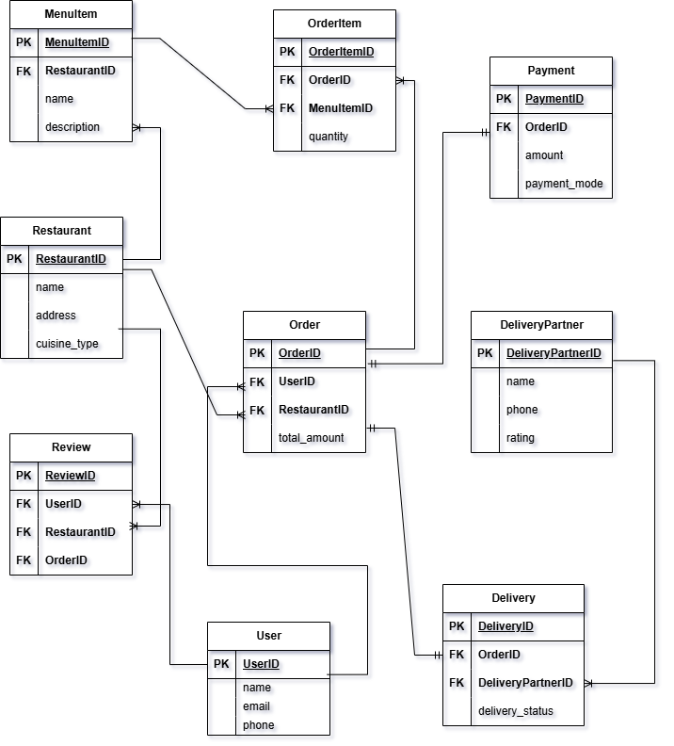

Conclusion

Swiggy is a strong example of how technology, when designed around real human needs, can transform an entire industry. Through this case study, we explored how Swiggy simultaneously addresses the challenges faced by customers, restaurants, and delivery partners through a well-integrated set of features — from location-based discovery and real-time tracking to verified reviews and seamless payments.
The schema design backing this platform reflects the same level of thoughtfulness, with clearly defined entities, relationships, and design choices that ensure data accuracy, scalability, and operational efficiency. Together, the product design and database structure demonstrate how a robust digital platform can create value for every stakeholder it serves, making Swiggy an indispensable part of modern urban life.

